AN EFFICIENT NOVEL APPROACH FOR PREDICTING STARTUP COMPANY SUCCESS RATES USING ADVANCED MACHINE LEARNING PARADIGMS
Scope and Limitations
Department of Computer Science and Engineering, [COLLEGE NAME]
Batch C10 (CSE-C) · Academic year [ACADEMIC YEAR]
Table 1: Project team
S.No. | Student name | Roll number
1 | Orchu Shirisha | 23K91A05H6
2 | Mudavath Raghavendar | 23K91A05G1
3 | Majgi Vaishnavi | 23K91A05E0
4 | Polishetty Poojitha | 23K91A05J4

Project guide: P Prasanna
Chapter and section numbers quoted in the text (for example Chapter 8 or Section 6.2) refer to the full project report, 17.Final Document. Figures and tables in this document are numbered from 1.

1. SCOPE

1.1 In scope
• Binary classification of an early-stage startup as SUCCESS (acquired or IPO) or FAILURE (closed), with probabilities, a confidence and a risk label.
• Structured inputs: funding total and rounds, ages at first and last funding and milestone, relationships, milestones, average participants, seven flags (VC, angel, rounds A to D, top-500), state and industry; an optional description of up to 2,000 characters; k from {10, 20, 30, 50}.
• Preprocessing (median and most-frequent imputation, standardisation, one-hot encoding, log funding), a MiniLM text embedding, weighted fusion and balanced cosine retrieval of comparable startups.
• Four classifiers (Logistic Regression, Decision Tree, Random Forest, XGBoost) selected by balanced accuracy, with explanations from coefficients or importances.
• A local web application: landing page, demo sign-in, dashboard, analyse form and result, model performance and insights, plus the original server-rendered pages.
• Evaluation on the real public table (922 rows) and on the shipped synthetic fallback: accuracy, balanced accuracy, precision, recall, F1, ROC-AUC, confusion matrices, class-imbalance, threshold, calibration, ablation and latency studies. Hardware used: Intel Core i5-12500 (6 cores, 12 threads), 15.7 GB RAM, Windows 11 Pro, CPU only (no GPU).

1.2 Out of scope
• Investment advice or any guarantee of a startup's future. The output is an analytical estimate.
• Founder background, team experience, market trends, patents and social-media signals; they are named in the abstract but exist in neither dataset.
• Temporal validation, because the public table carries no usable dates.
• Deep-learning classifiers, a language model, SHAP values and GPU training.
• Authentication beyond a demo token, multi-user operation, a SQL database, cloud deployment and load handling.
• Datasets other than the US-centred public table and the synthetic fallback.

1.3 Users and environment
The intended user is a student, teacher or analyst who runs the application locally (Windows, Python 3.11 and Node.js 20 or newer, started with run.bat) and uses it as a screening aid and as a teaching example of a classifier with retrieved evidence. The backend listens on 127.0.0.1:8410 and the React frontend on port 5410; no data leaves the computer and no external prediction service is called.

2. ASSUMPTIONS
• Historical startup records carry some signal about later outcomes through funding, milestones, relationships, sector and location. The experiments confirm a moderate signal; they do not show that these fields cause success.
• The outcome mapping is reasonable: acquired or IPO is SUCCESS, closed is FAILURE, and a startup that is still operating has no label and is outside the data.
• The public 923-row table (922 rows after de-duplication) is representative enough of US startups of its period to compare models; it is not a sample of any other country.
• The fields age_last_milestone_year, milestones and relationships are usable as inputs, although part of them may be recorded after the outcome window (see limitation L2).
• Description text, when given, is the company's own summary, with the company name masked before embedding.
• The application runs on a trusted local machine and the user types their own inputs.
• The libraries match requirements.txt (scikit-learn 1.5.2, pandas 2.2.3); model files saved by newer versions may fail to load.

3. LIMITATIONS
The following limitations apply to the system and to the conclusions of this report. They are numbered so that other chapters can refer to them.
L1. The shipped model is trained on synthetic data. The Kaggle download needs a login, so the model in models/ was fitted to a 1,400-row synthetic fallback (595 success, 805 failure) generated from templates. Its balanced accuracy of 0.749 (Logistic Regression, fused features) is a pipeline check, not evidence of real-world skill, and its description text differs between classes by construction.
L2. Leakage-like fields. relationships, milestones and the two milestone-age fields are recorded around or after the outcome window and the table has no time stamps to remove them. Dropping them lowers ROC-AUC from 0.816 to 0.719 (Random Forest) and from 0.806 to 0.699 (XGBoost). The real-data numbers are an upper bound for early-stage prediction [29, 9].
L3. No temporal split. Training and test rows are drawn at random, so look-ahead bias cannot be excluded, a problem that the base paper itself raises and that a time-based split would address.
L4. One small US dataset. All real measurements use 922 US startups; five 80/20 splits give test folds of 185 rows, so differences of about 0.03 in balanced accuracy are within the split-to-split spread. Small industries (Biotech, CleanTech: 6 test rows each) cannot be assessed.
L5. The text channel is untested on real startups. The public table has no descriptions. The benefit of the MiniLM embedding and of the fused retrieval is therefore measured only on synthetic text that leaks the label.
L6. No founder, team-experience or market data. The abstract and the objectives name these inputs; neither dataset contains them. Funding velocity is only approximated by the ages at first and last funding and the number of rounds.
L7. Class balance differs from the assumption. In the real table SUCCESS is the majority (64.6%). Class weights and oversampling did not raise ROC-AUC; they only trade recall of success for precision.
L8. Probabilities are not calibrated. A class-weighted logistic regression underestimates P(success) in the middle range on the real data (for example predicted 0.35, observed 0.65 in the 0.3-0.4 bin). The confidence shown is max(P) and is not a guarantee.
L9. Model selection rule versus data. The application picks the best model by balanced accuracy on its own training data; on the synthetic table that is Logistic Regression, on the real table XGBoost and Random Forest tie. A retrain on real data would therefore change the served model.
L10. Operational limits. No database, no multi-user support, a demo HMAC token for sign-in, no load or security test; the sentence-transformers model is loaded on the first request and, if unavailable, a hashing fallback embedding is used. Hardware: Intel Core i5-12500 (6 cores, 12 threads), 15.7 GB RAM, Windows 11 Pro, CPU only (no GPU).
Three figures illustrate the main limitations. The first shows the class balance of the two tables: the shipped application runs on a synthetic table in which failure is the larger class, whereas in the real table success is the larger class. The second shows how much of the real-data performance depends on fields that are recorded around or after the outcome. The third shows how closely the predicted probabilities of Logistic Regression follow the observed success rates on the real table.
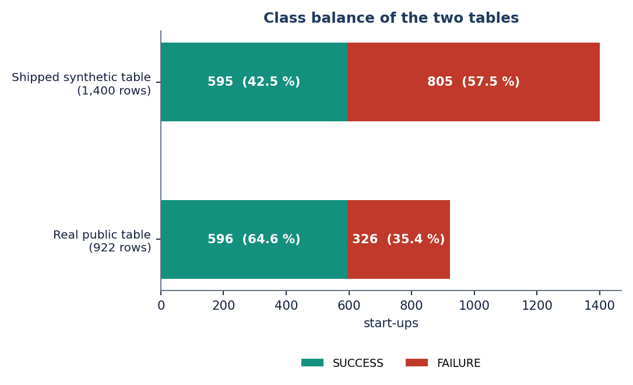
Figure 1: Class balance of the shipped synthetic table and of the real public table.
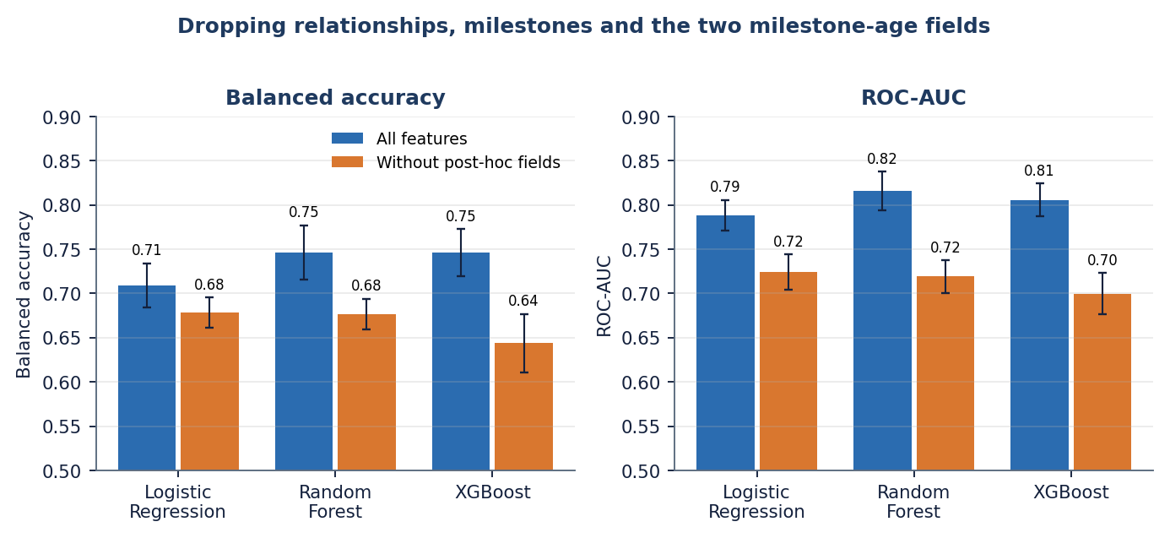
Figure 2: Performance with all features and without the four fields recorded around or after the outcome (real table).
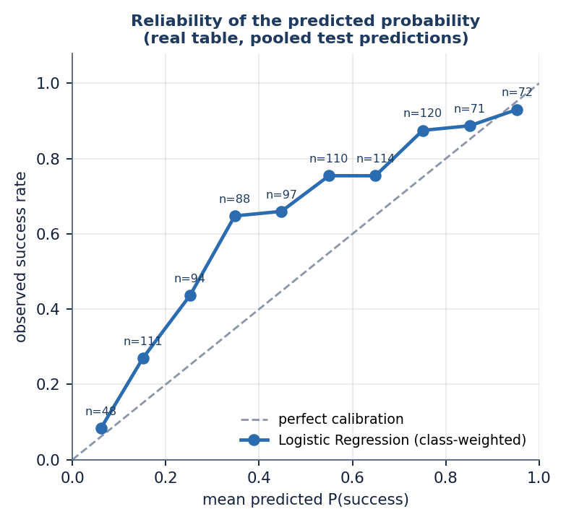
Figure 3: Predicted probability against observed success rate, Logistic Regression, real table.

4. WHAT WAS NOT MEASURED
The following were not measured, and no figure for them appears in this report.
Table 2: Items not measured
Item | Why it matters | Status
Performance on a time-based (out-of-time) split | Look-ahead bias cannot be excluded without it | Not run: the table has no dates
Effect of the text embedding and of fused retrieval on real startups | The main novelty claim of the application | Not run: the real table has no descriptions
ROC-AUC of the shipped fused model | Threshold-free ranking quality of the served model | Not recorded by the application's own evaluation
Founder experience, team size and market-trend features | Named in the abstract and the objectives | Not available in either dataset
Statistical significance of differences between models | Differences of 0.01 to 0.03 are within the spread of five splits | Not tested
SHAP values and other model-agnostic explanations | The explanations shown are coefficient and importance terms | Not computed
Other datasets and other countries | Generalisation beyond 922 US startups | Not run
Hyper-parameter search for each model | Defaults and fixed settings may be far from the best | Not run; Random Forest size varied only
Concurrent users, memory under load, long-running behaviour | Deployment readiness | Not tested; only sequential requests were timed
A user study of the interface | Whether founders and investors understand the evidence | Not carried out
Security review and penetration test | Input handling beyond localhost | Only input validation and token checks were tested

